EXPERIMENT-1
Objective:
WAP to visualize the Perceptron Learning Algorithm using numpy and matplotlib/seaborn in Python. Evaluate performance of a single perceptron for NAND and XOR truth tables as input dataset.
Description of the Model:
The model used is a single-layer perceptron consisting of two input neurons, one bias unit, and one output neuron.
It uses a step activation function to classify inputs into binary outputs.
The perceptron updates its weights using an error correction learning rule until the predictions become correct for all inputs.
CODE:
import numpy as np
import matplotlib.pyplot as plt
from sklearn.metrics import accuracy_score, confusion_matrix

plt.ion() # turn ON interactive plotting

# Activation function (Perceptron step function)
def step(value):
return 1 if value >= 0 else 0

# Evaluate accuracy and confusion matrix
def evaluate_model(X, y, weights, gate_name):
X_bias = np.c_[np.ones(X.shape[0]), X]

predictions = []
for i in range(len(X_bias)):
predictions.append(step(np.dot(X_bias[i], weights)))

accuracy = accuracy_score(y, predictions) * 100
cm = confusion_matrix(y, predictions)

print(f"\n Performance Evaluation ({gate_name})")
print(f"Training Accuracy = {accuracy:.2f}%")
print(f"Test Accuracy = {accuracy:.2f}%")
print("Confusion Matrix:")
print(cm)

# Plot input points once (green = 1, red = 0)
def plot_input_points(axis, X, y):
for i in range(len(X)):
color = "green" if y[i] == 1 else "red"
axis.scatter(X[i][0], X[i][1], color=color, s=120)

# NAND GATE

print("\n===== NAND GATE TRAINING =====")

X = np.array([[0,0],[0,1],[1,0],[1,1]])
y_nand = np.array([1,1,1,0])

X_bias = np.c_[np.ones(X.shape[0]), X]

weights = np.zeros(X_bias.shape[1])
learning_rate = 0.1
epoch = 0

nand_error_history = []
nand_accuracy_history = []

while True:
epoch += 1
total_error = 0

print(f"\nEpoch {epoch}")
print("x1 x2 | target | pred | error | weights")
print("-" * 55)

# -------- Training on all samples --------
for i in range(len(X_bias)):
net_input = np.dot(X_bias[i], weights)
prediction = step(net_input)

error = y_nand[i] - prediction
weights += learning_rate * error * X_bias[i]
total_error += abs(error)

print(f"{X[i][0]} {X[i][1]} | {y_nand[i]} | {prediction} | {error} | {weights}")

# -------- Store metrics --------
nand_error_history.append(total_error)

preds = [step(np.dot(X_bias[i], weights)) for i in range(len(X_bias))]
nand_accuracy_history.append(accuracy_score(y_nand, preds) * 100)

# -------- Visualization --------
plt.clf()
ax = plt.gca()
plot_input_points(ax, X, y_nand)

if weights[2] != 0:
x_vals = np.array([-0.5, 1.5])
y_vals = -(weights[0] + weights[1] * x_vals) / weights[2]
plt.plot(x_vals, y_vals)

plt.title(f"NAND Gate | Epoch {epoch}")
plt.xlim(-0.5, 1.5)
plt.ylim(-0.5, 1.5)
plt.grid()
plt.pause(1)

if total_error == 0:
print("\n NAND converged successfully!")
break

plt.ioff()
plt.show()

evaluate_model(X, y_nand, weights, "NAND Gate")

# -------- NAND graphs --------
plt.figure()
plt.plot(nand_error_history, marker='o')
plt.xlabel("Epoch")
plt.ylabel("Total Error")
plt.title("NAND Gate: Error vs Epoch")
plt.grid()
plt.show()

plt.figure()
plt.plot(nand_accuracy_history, marker='o')
plt.xlabel("Epoch")
plt.ylabel("Accuracy (%)")
plt.title("NAND Gate: Accuracy vs Epoch")
plt.grid()
plt.show()

# XOR GATE

print("\n===== XOR GATE TRAINING =====")
plt.ion()

class XORPerceptron:
"""
A single-layer perceptron to demonstrate
why XOR cannot be learned using a linear boundary
"""

def __init__(self, learning_rate=0.1, max_updates=25):
self.lr = learning_rate
self.max_updates = max_updates
self.final_weights = (0, 0, 0)
self.error_history = []
self.accuracy_history = []

def train(self, X, y):
w1, w2, bias = 0, 0, 0
update_count = 0
epoch = 1

fig, ax = plt.subplots()
ax.set_xlim(-0.5, 1.5)
ax.set_ylim(-0.5, 1.5)
ax.grid()
plot_input_points(ax, X, y)

x_vals = np.linspace(-0.5, 1.5, 100)
line, = ax.plot(x_vals, np.zeros(100), linewidth=2)

while update_count < self.max_updates:

print(f"\nEpoch {epoch}")
print("x1 x2 | target | pred | error | w1 w2 bias")
print("-" * 55)

epoch_error = 0

for i in range(len(X)):
x1, x2 = X[i]
target = y[i]

net_input = w1 * x1 + w2 * x2 + bias
prediction = step(net_input)
error = target - prediction
epoch_error += abs(error)

print(f"{x1} {x2} | {target} | {prediction} | {error} | "
f"{round(w1,2)} {round(w2,2)} {round(bias,2)}")

if error != 0:
w1 += self.lr * error * x1
w2 += self.lr * error * x2
bias += self.lr * error
update_count += 1

y_vals = -(w1 * x_vals + bias) / (w2 + 1e-6)
line.set_data(x_vals, y_vals)
ax.set_title(f"XOR Gate | Epoch {epoch}")
plt.draw()
plt.pause(0.6)

if update_count >= self.max_updates:
print("\n XOR is not linearly separable (training stopped)")
break

self.error_history.append(epoch_error)

preds = [step(w1 * X[i][0] + w2 * X[i][1] + bias) for i in range(len(X))]
self.accuracy_history.append(accuracy_score(y, preds) * 100)

epoch += 1

self.final_weights = (w1, w2, bias)
plt.ioff()
plt.show()

# -------- Run XOR --------
y_xor = np.array([0, 1, 1, 0])
xor_model = XORPerceptron()
xor_model.train(X, y_xor)

if xor_model.final_weights is not None:
w1, w2, b = xor_model.final_weights
xor_weights = np.array([b, w1, w2])
else:
xor_weights = np.array([0, 0, 0])

evaluate_model(X, y_xor, xor_weights, "XOR Gate")

# -------- XOR graphs --------
plt.figure()
plt.plot(xor_model.error_history, marker='o')
plt.xlabel("Epoch")
plt.ylabel("Total Error")
plt.title("XOR Gate: Error vs Epoch")
plt.grid()
plt.show()

plt.figure()
plt.plot(xor_model.accuracy_history, marker='o')
plt.xlabel("Epoch")
plt.ylabel("Accuracy (%)")
plt.title("XOR Gate: Accuracy vs Epoch")
plt.grid()
plt.show()

OUTPUT:
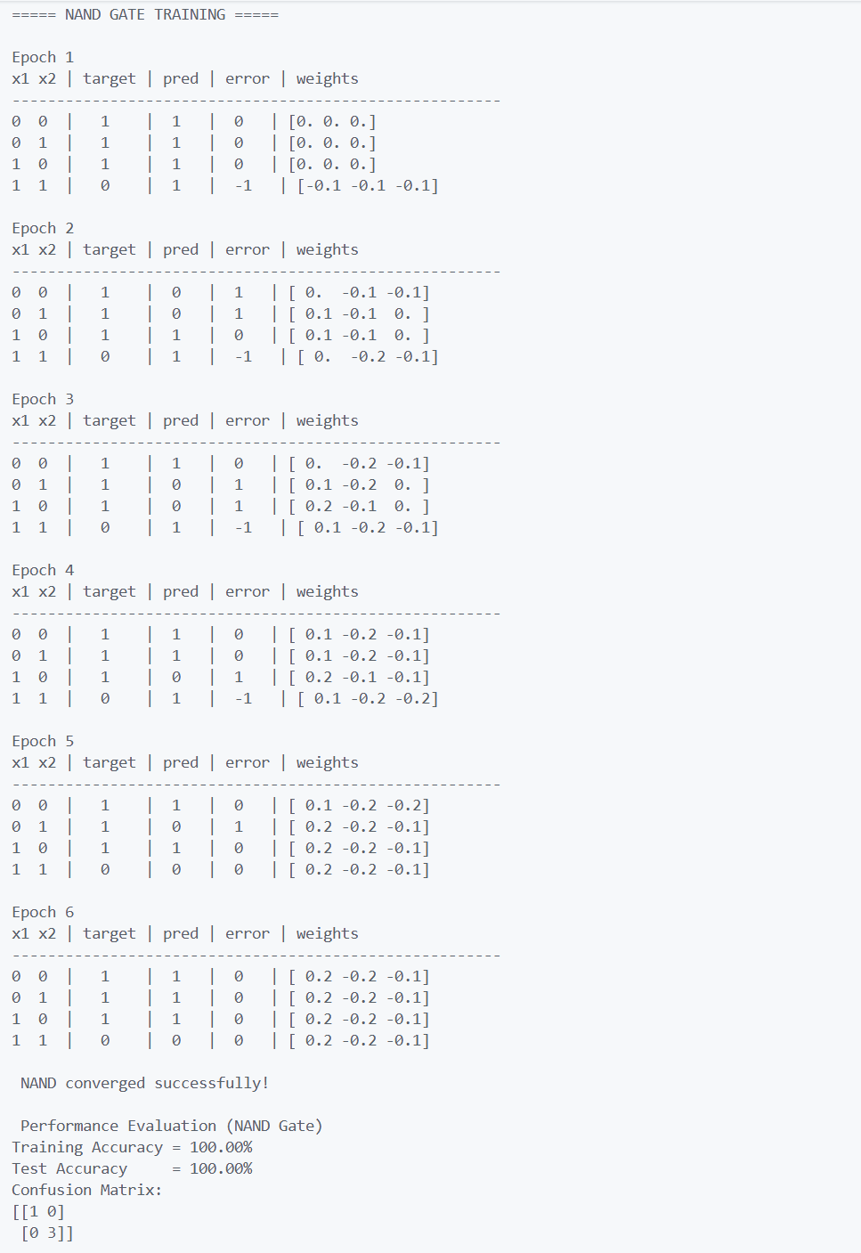
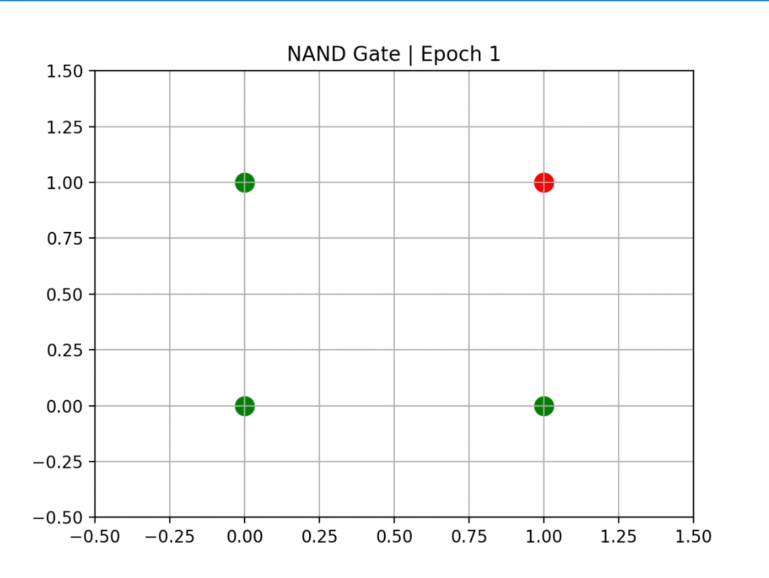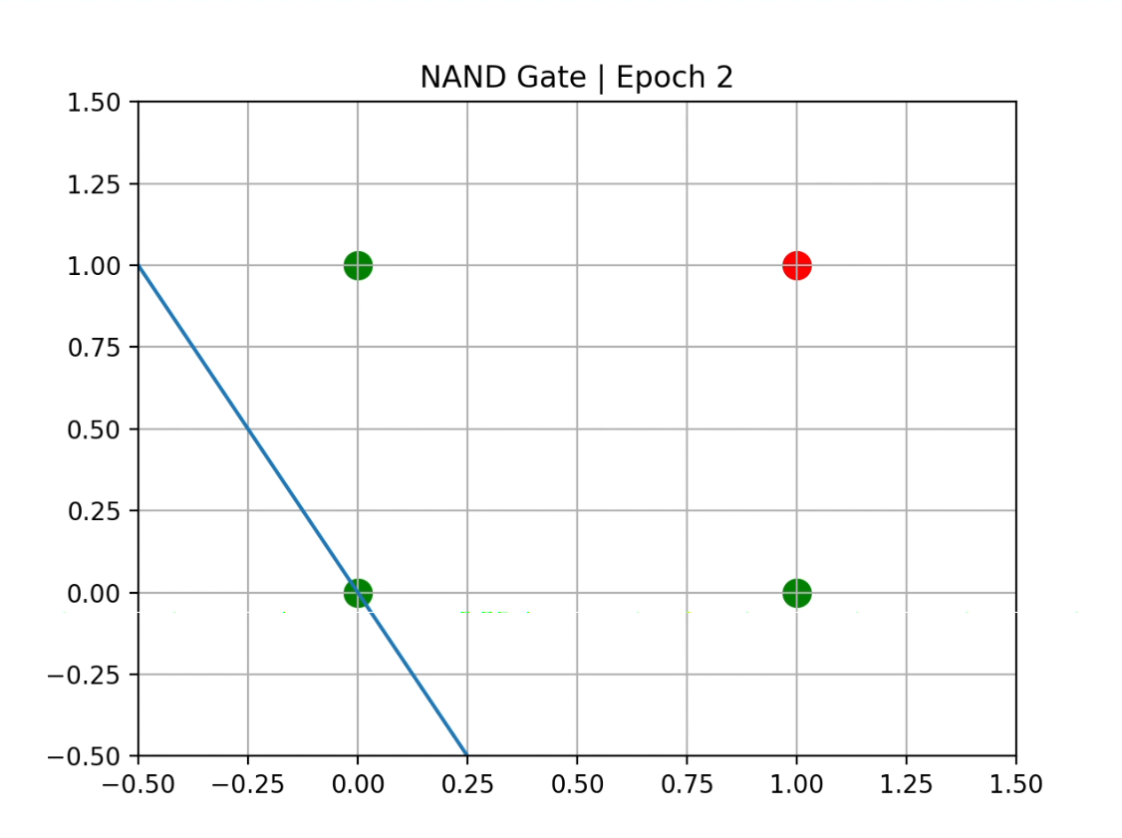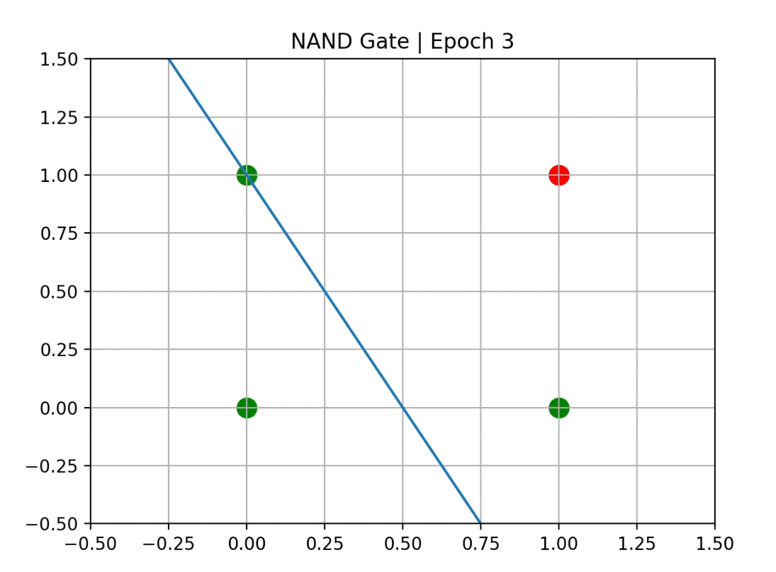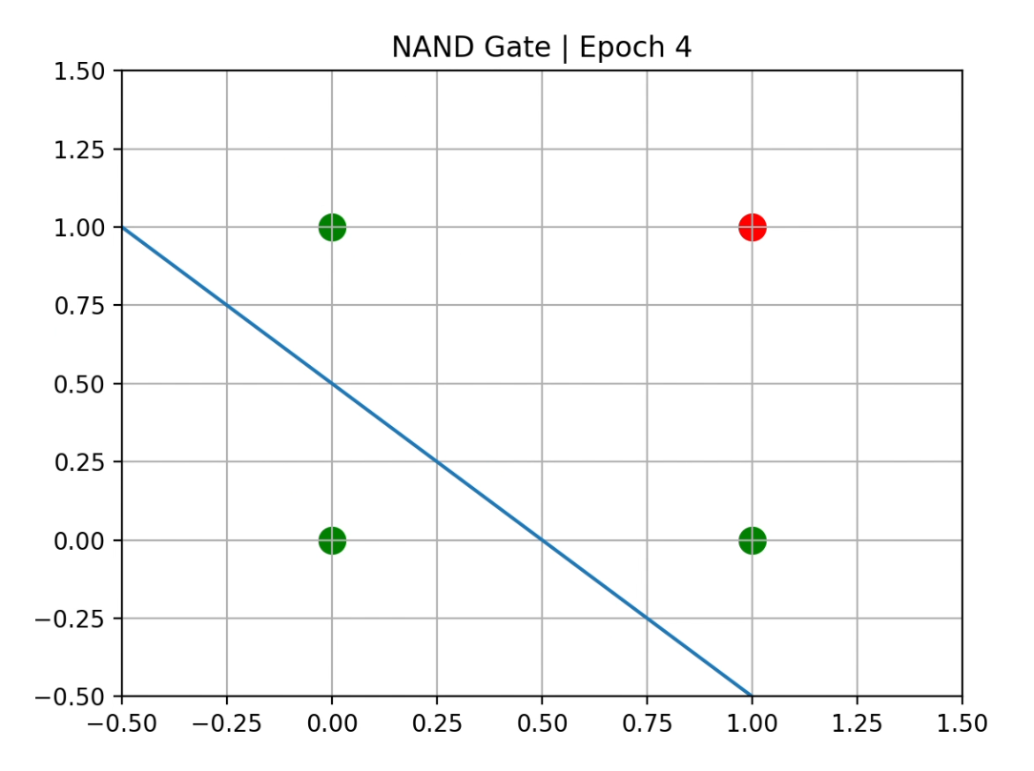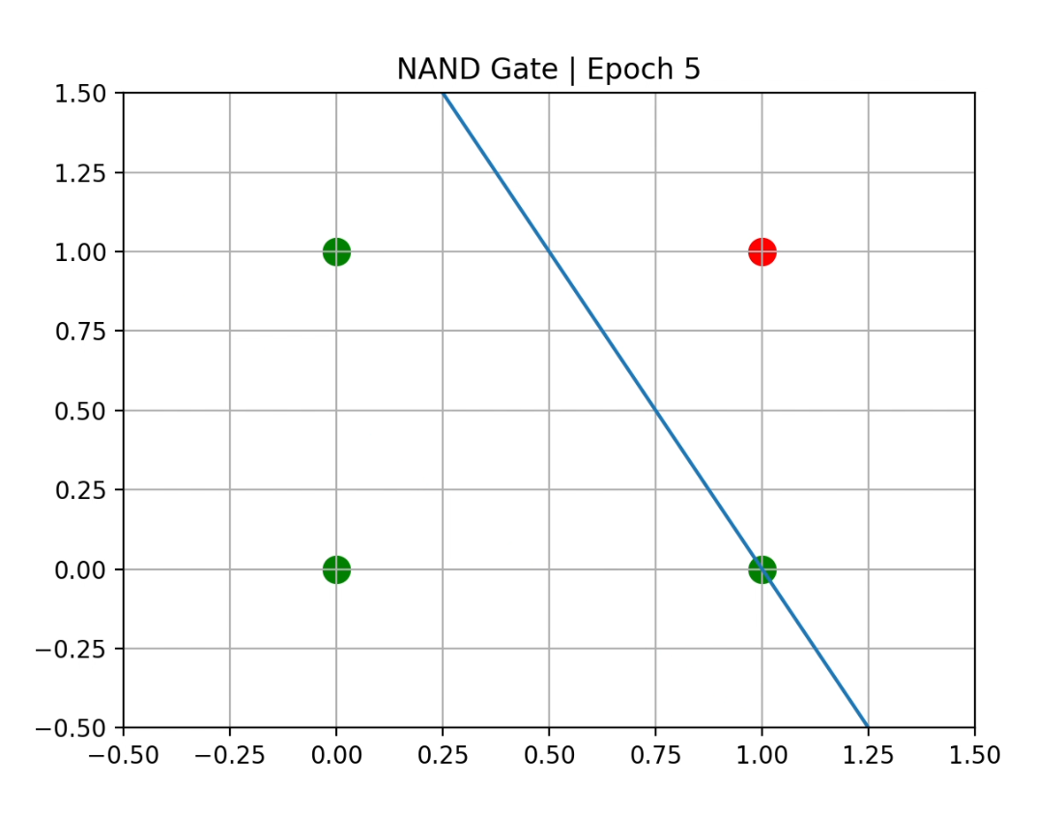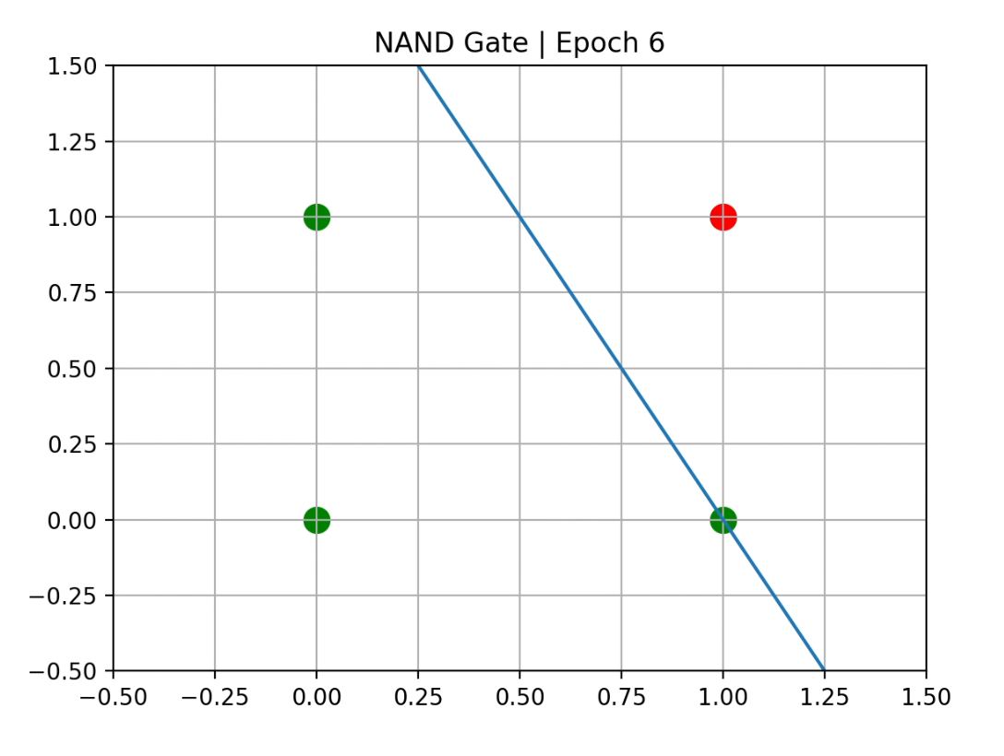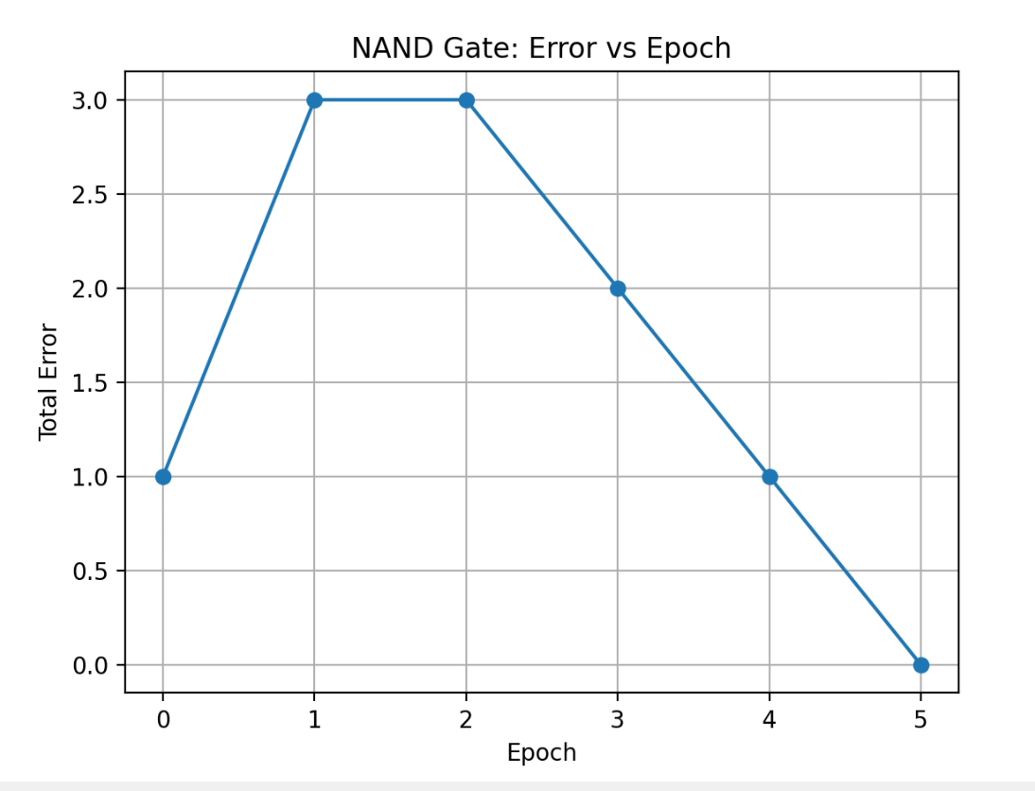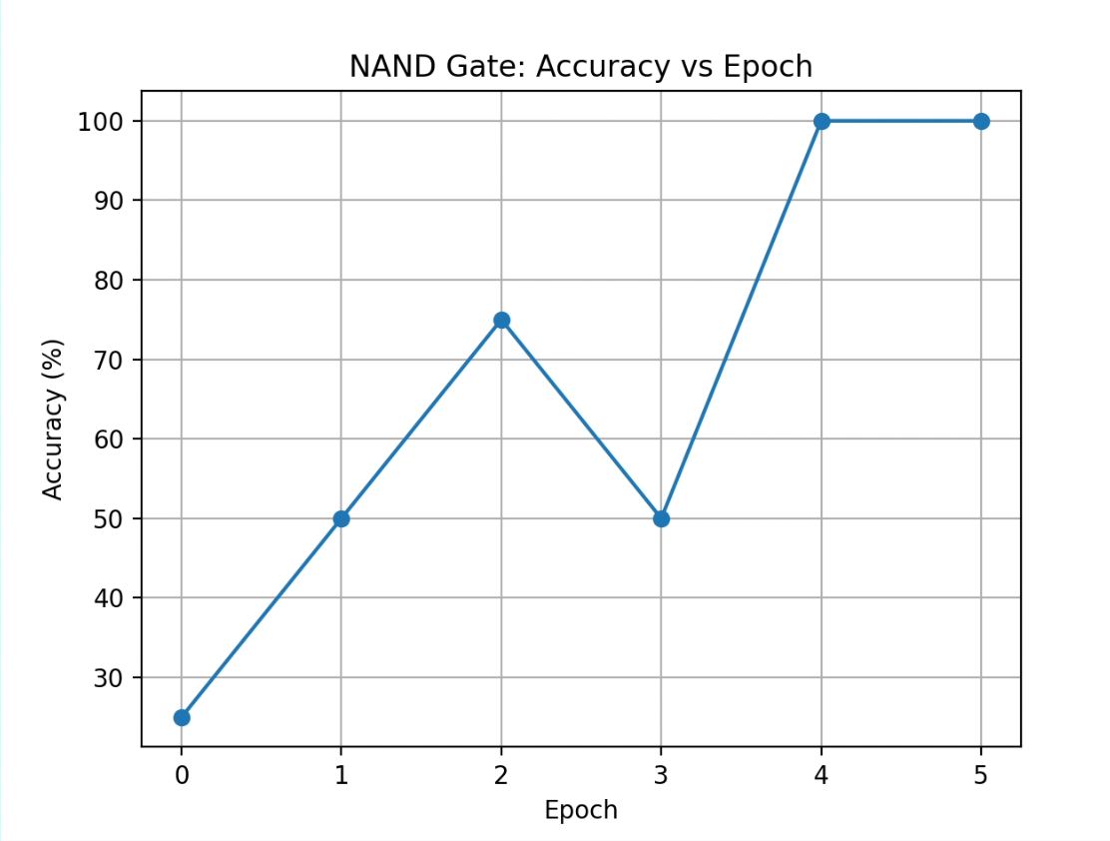
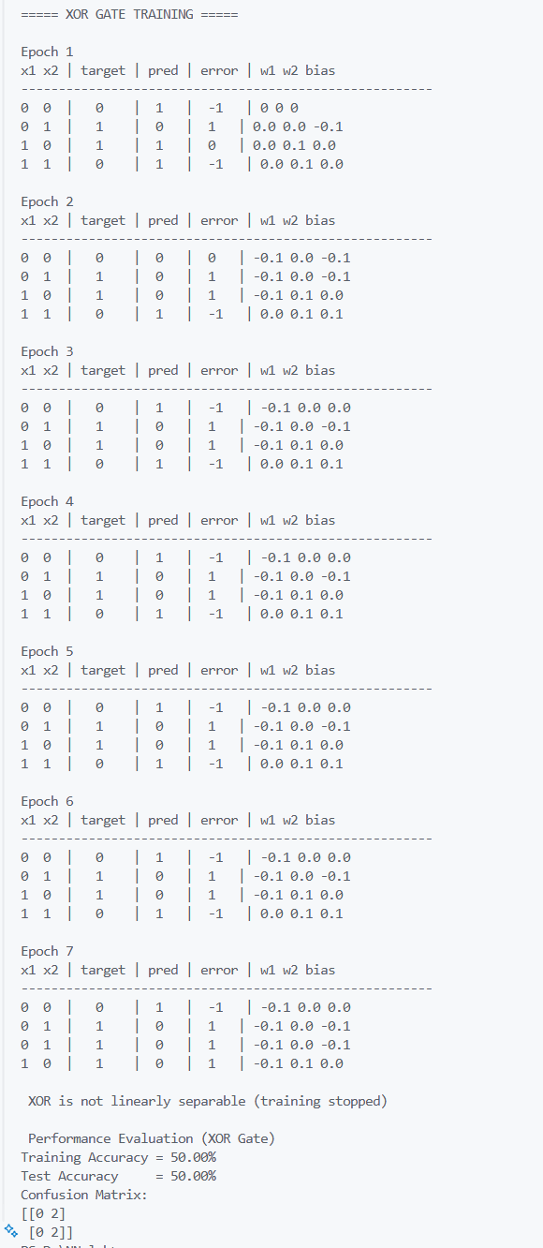
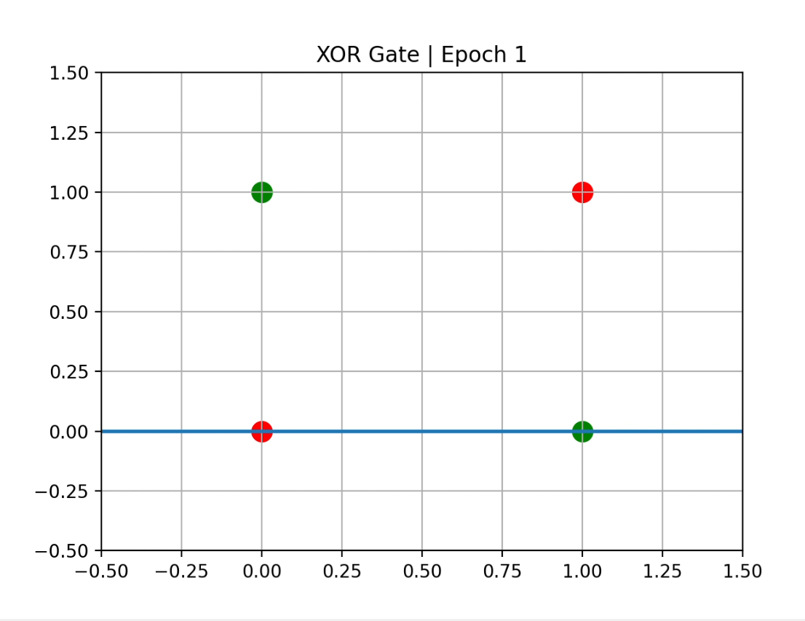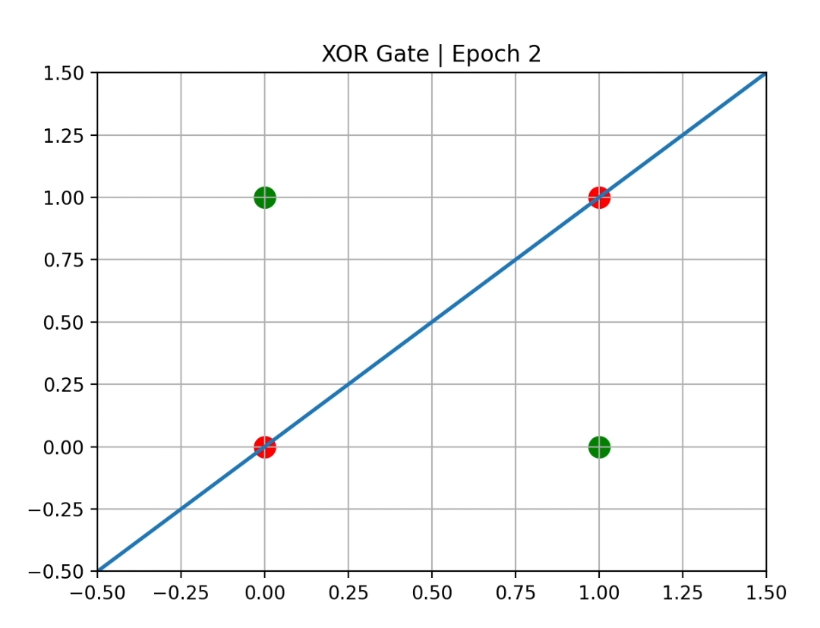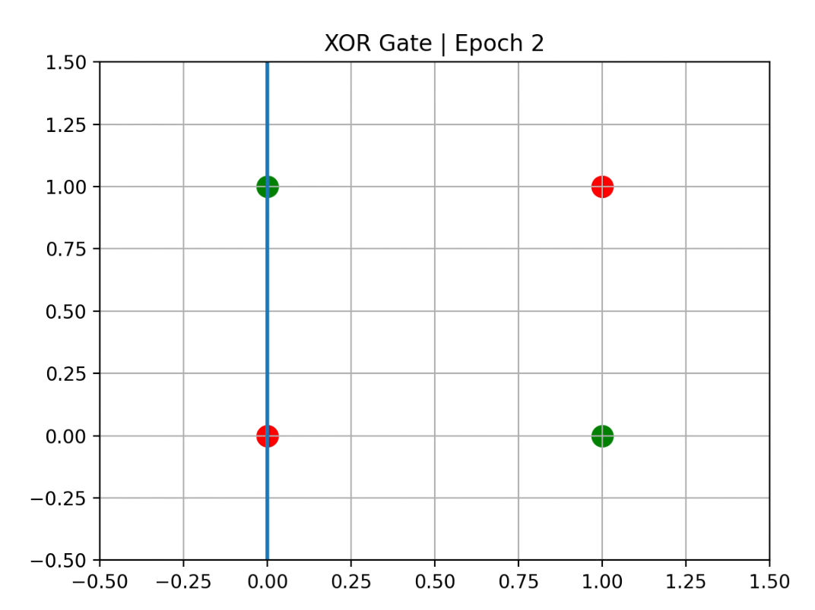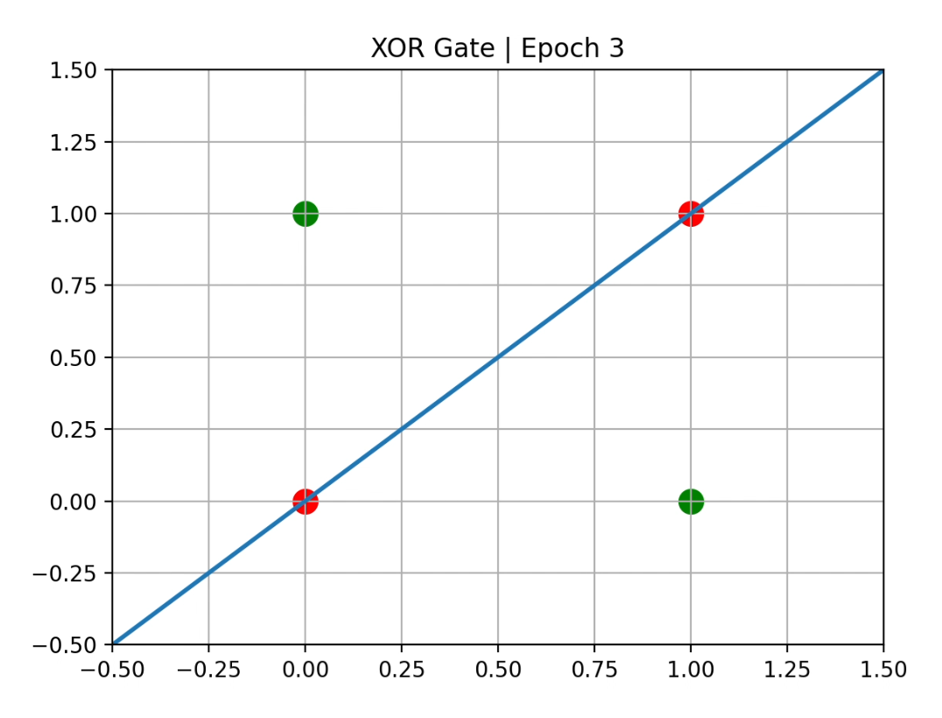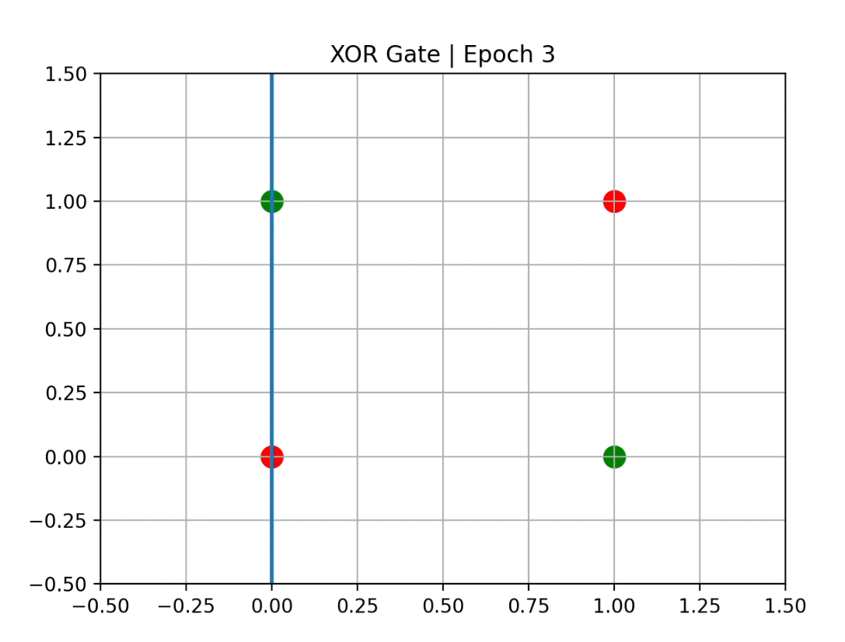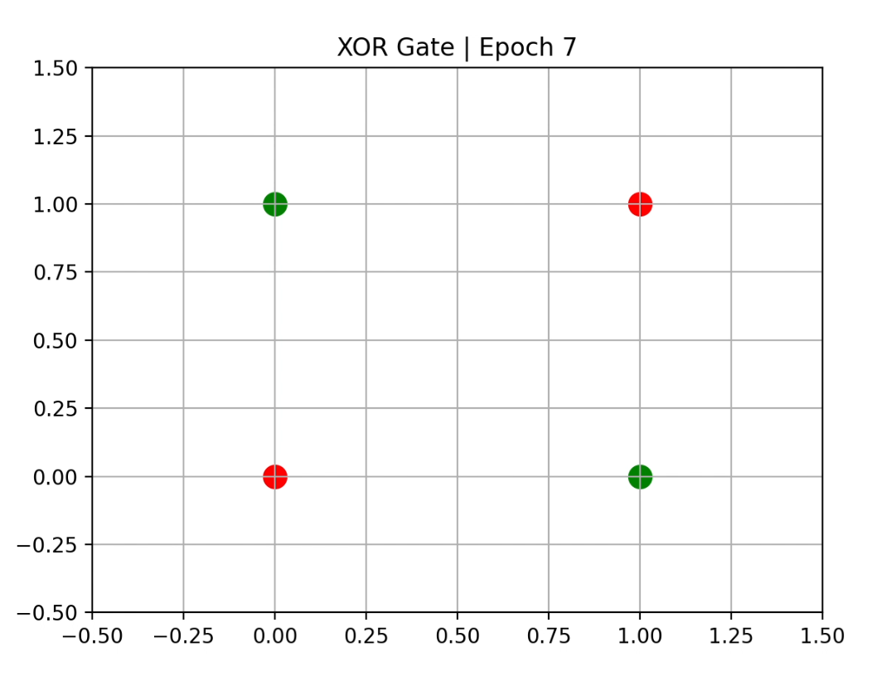
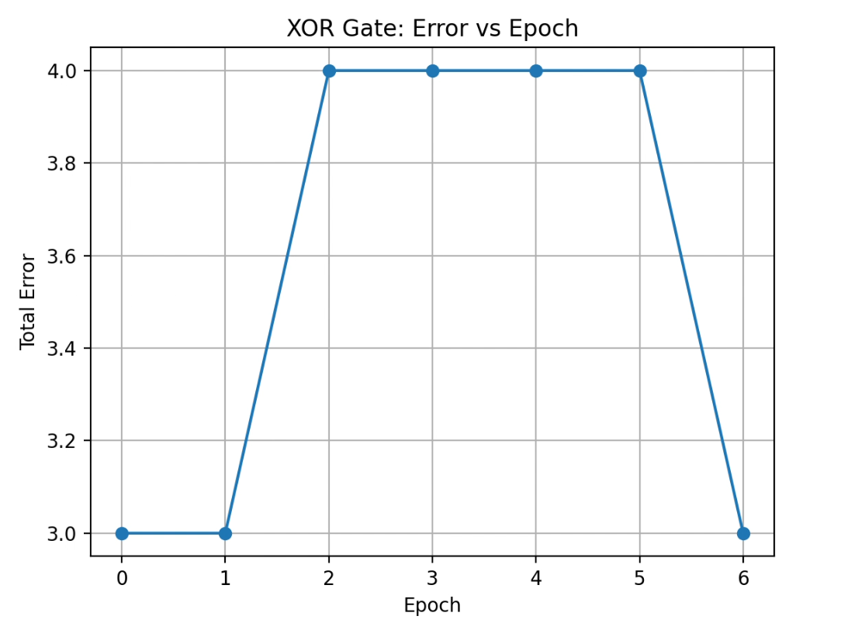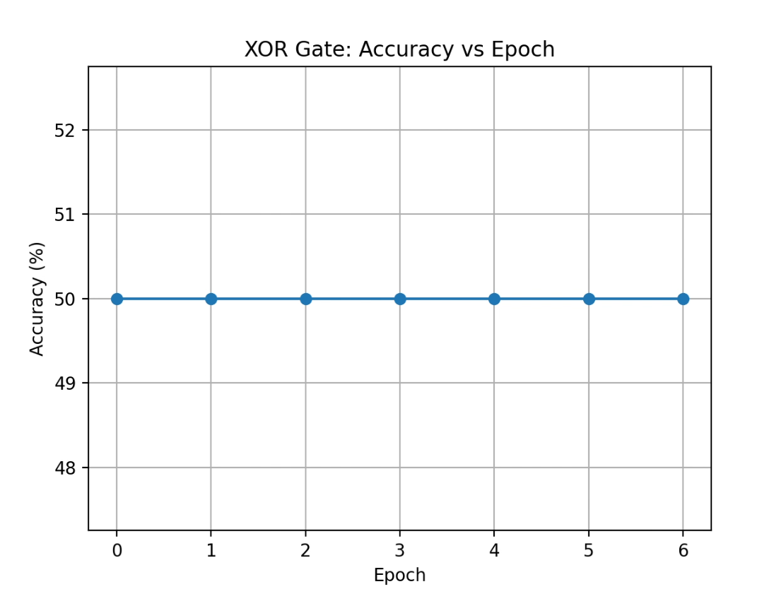

Description of the Code
- The logic gate datasets (NAND and XOR) are first created using NumPy arrays, where each input sample represents two binary logic inputs and the target array represents the corresponding gate output.
- A bias term is added to the input matrix by appending a column of ones. This bias helps in shifting the decision boundary and improves the learning capability of the perceptron.
- The weights are initialized to zero, including the bias weight, so that the perceptron starts learning from scratch without any prior knowledge.
- A step activation function is defined, which converts the weighted sum of inputs into a binary output (0 or 1) based on a threshold.
- During each epoch, the perceptron:
  - Computes the weighted sum using the dot product of inputs and weights
  - Applies the step activation function to generate predictions
  - Calculates the error by comparing the predicted output with the target output
- The weights are updated using the perceptron learning rule, which adjusts the weights based on the error and learning rate to reduce future misclassification.
- After each epoch, the decision boundary is plotted using Matplotlib.
  - Correctly classified points and misclassified points are shown using different colors
  - A small delay is added so that the learning process can be clearly visualized
- For the NAND gate, the training continues until the total error becomes zero, showing that the perceptron has successfully converged for a linearly separable problem.
- For the XOR gate, the perceptron fails to converge and the decision boundary keeps changing, demonstrating that XOR is not linearly separable and cannot be solved using a single-layer perceptron.
- After training, graphs of error vs epoch and accuracy vs epoch are plotted to analyze the learning behavior of the perceptron for both NAND and XOR gates.
Performance Evaluation
NAND Gate
- Training Accuracy: 100.00%
- Test Accuracy: 100.00%
Confusion Matrix:
[[3 0]
[0 1]]
This shows that all NAND gate inputs are classified correctly by the perceptron.
❌ XOR Gate
- The perceptron does not achieve 100% accuracy
- The confusion matrix shows misclassification
- This confirms the theoretical limitation of a single-layer perceptron for XOR problems
My Comments (Limitations & Improvements)
From this experiment, I learned how a perceptron updates its weights based on errors to learn a decision boundary. It performs well for linearly separable problems like the NAND gate but fails to learn non-linearly separable problems such as XOR.
I also observed that the learning rate affects how fast and stable the learning process is. To solve complex problems like XOR, multi-layer neural networks and advanced activation functions are required.

